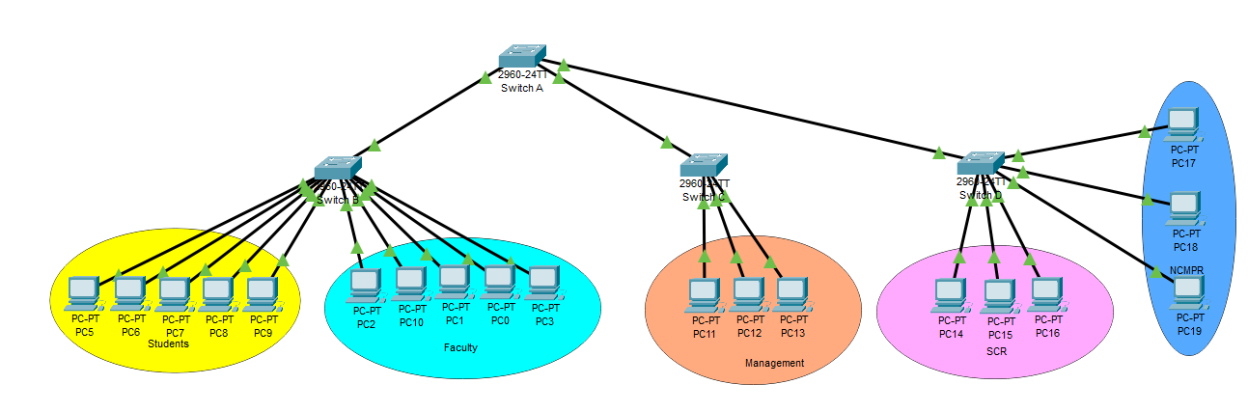

**SWITCH 1 Password Encryption**

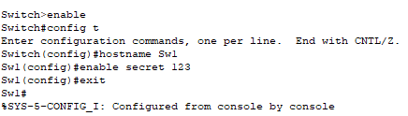

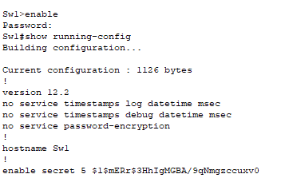

**SWITCH 2 Password Encryption**

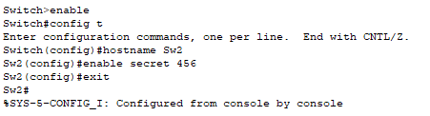

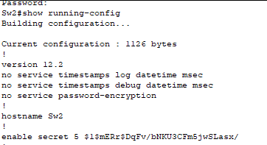

**SWITCH 3 Password Encryption**

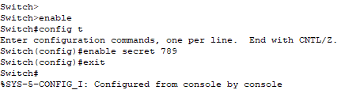

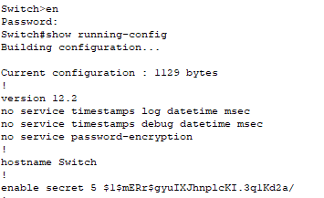

**SWITCH 4 Password Encryption**

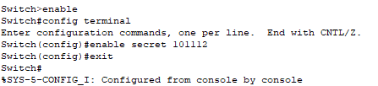

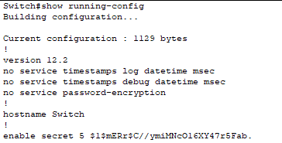

***Before Setting up vlan,packets are sent successfully between the computers of different switches but we want to stop this to limit the communication so we gonna be configuring the vlan***

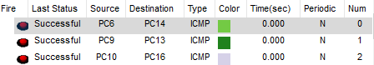

**Setting up vlan in SwitchB**

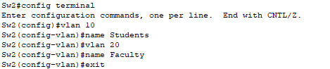

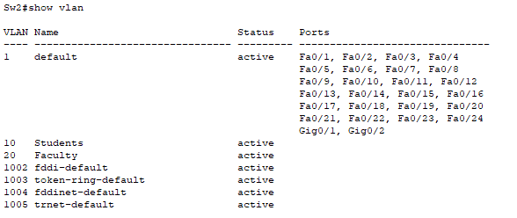

**Setting up vlan in SwitchC**

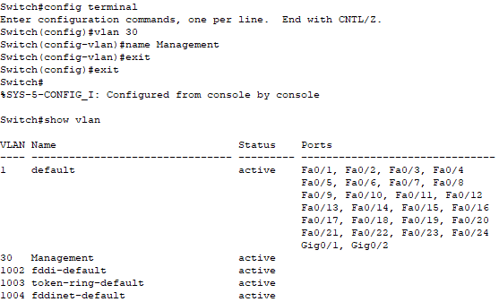

**Setting up vlan in SwitchD** 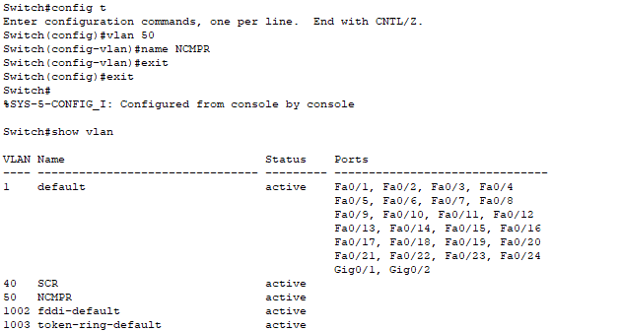

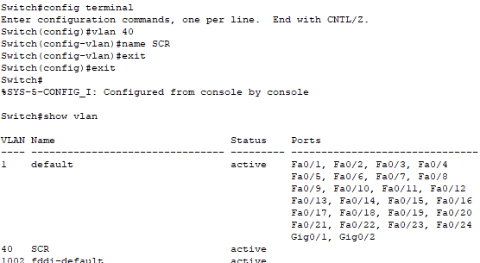

**Configuring Students to SwitchB**

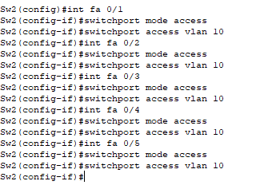

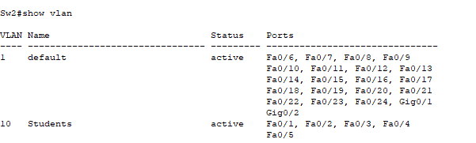

**Configuring Faculty to SwitchB**

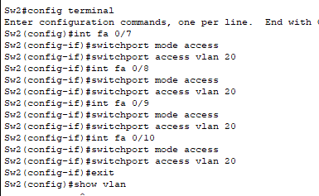

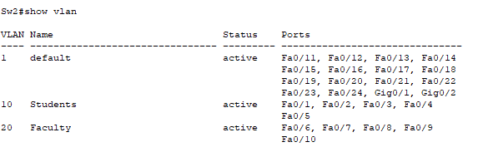

**Configuring Management to SwitchC**

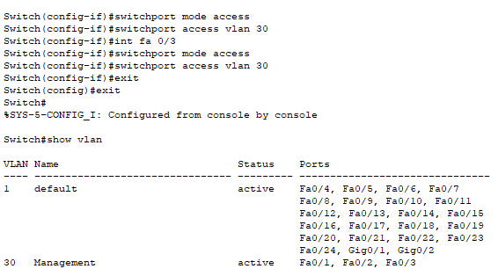

**Configuring SRC to SwitchD**

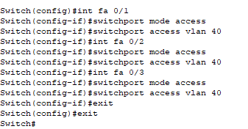

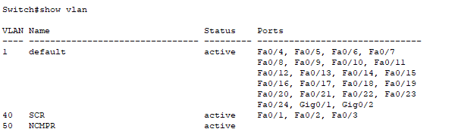

**Configuring NCMRP to SwitchD**

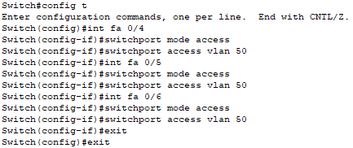

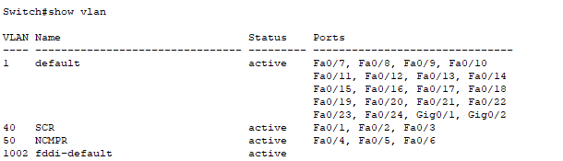

**From Student to Student**



**From Faculty to Faculty** 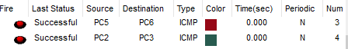

**Within Management**



**Within SRC**



**Within NCMPR**



**Packets Sent Within Different vlans**

